Date : 20.09.2022

Linux used in LAB :: Redhat linux NGI

**Ques 1 :** Inverted directory tree structure of Linux

**Ques 2 :** Suse, ubuntu, fedora, lendrick : different variations of Linux. Now you have to make a list of flavors available on Linux (versions).

Ans : Android, arch linux, centos, debian, elementary OS, fedora Linux, Gento Linux, Kali Linux

* UNIX COMMANDS ($)

$ pwd : print working directory

$mkdir <dir name> : make directory

$ls : list

$ cd <dir name> : change directory

$cd : directly jump to your login id

$ cd .. : change to parent directory ( . . denote the parent directory)

Press cd .. in the home directory -> it shows all the user connected

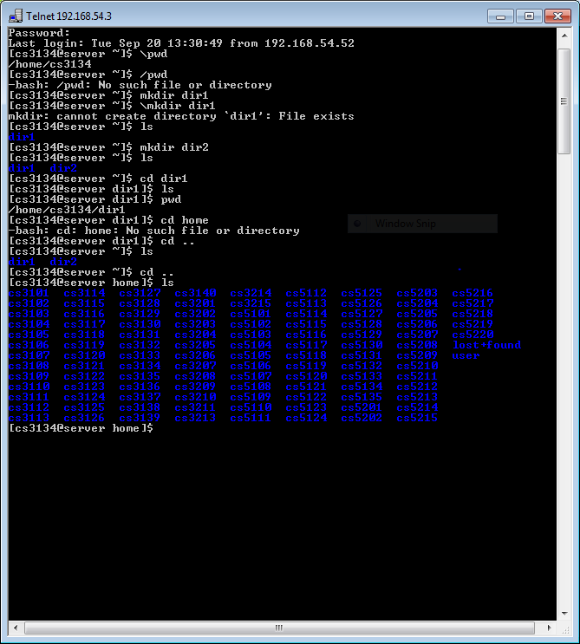

Press cd .. (again and again) and check the directory.

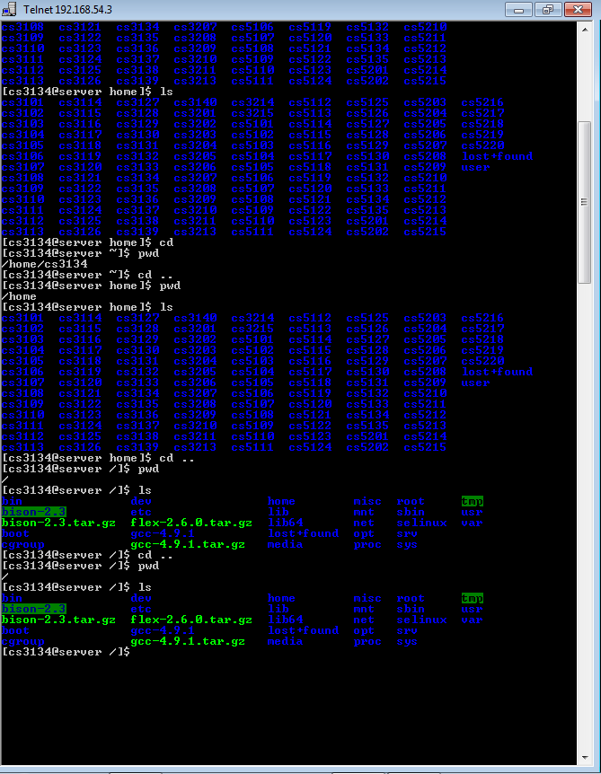

Also try : cd bin ; ls ;

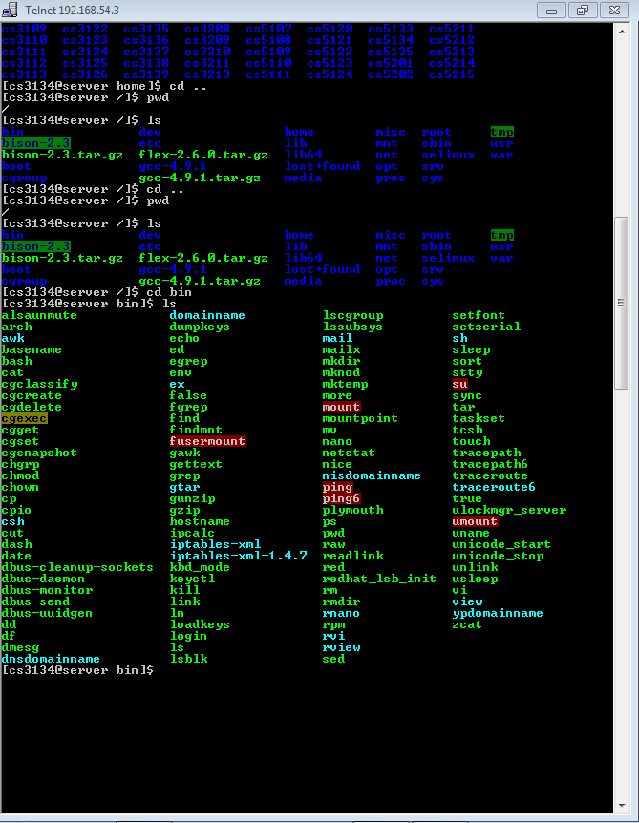

Also try, cd lib, etc.

$ cal : prints calendar

$touch <f1> <f2> <f2> : generates three blank files named f1, f2, f3

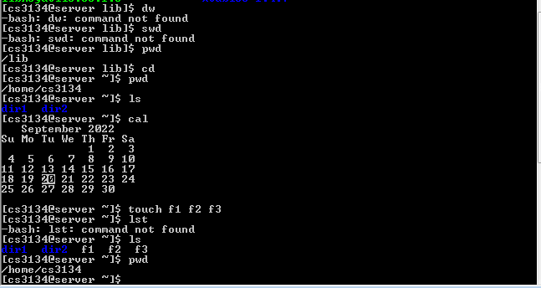

* Linux doesn’t allow the user to switch to other user’s directories. Also a user can alter the files in any location except its own home directory.

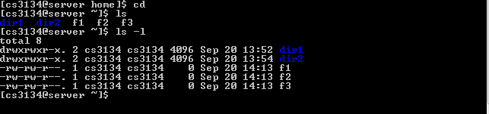

$ls –l : shows a seven column output (l stands for long list)

Explanation -> (

1st column begins with – or d where drwxrwxr-x means read write execute read write execute read execute, a row containing –rw-rw-r—means read write read write read ie. **The permissions given to the files or directory**

Rwx rwx r-x :row 1

111 111 101 :binary (1 for r/w/x)

7 7 5 :binary converted to decimal

2nd column shows the number of links . by default no of links for file is 1 and for the directory is 2.

3rd column shows the username of the login ID

4th column shows the group name . multiple users can be put in same group which grants permissions of edit, delete and execute to edit the files in the group to all the users

5th column shows the size of the directory/file

6th column shows the date and time when file was created

7th column shows the name of the directory or file

)

**Ques 3 : read, write, execute for a directory. Find the meaning.**

Ans : Read – means that user may see the contents of the directory

Write – means that user may create files in the directory

Execute – user may enter the directory (or make this a current directory)

**Ques 4: for next lab**

**Rndir :** Removes the directory

**Ls -a :** enlist the whole list of current directory including hidden file

**ls -lh :** gives data in terms of file size in human readable format

**ls –lhs :** displays the file in descending order

**ls –p :** identify directory easily by marking the directories with slash (/) line sign

**ls –r :** used to print list in reverse order

**ls –lX :** groups the file with same extensions together in the list

**Cal :** displays a calendar of the specified year or month

**Rm :** provides a way to insert remarks (that will not be acted on) into a batch file

**Man :**  used to display user manual of any command that we can run on the terminal

**Cp :**  copying files from one location to another

**Ln :**  create links to files or directories

**Mv :**  move files and directory from one location to another

**Assignment : create a virtual machine on your windows system (15-20 days). Install a virtual machine ubuntu.**

**Date : 21.09.2022**

**Homework : How to compile and execute a C++ program in UNIX / LINUX ?**

**change the permission of directory and then use ls command.**

**THE COMMANDS COVERED ~~**

**Rmdir <dir name> :** Removes the directory

**Rm <file name>** : removes the file

**Ls -a :** enlist the whole list of current directory including hidden file

**ls -lh :** gives data in terms of file size in human readable format

**ls –lhs :** displays the file in descending order

**ls –p :** identify directory easily by marking the directories with slash (/) line sign

**ls –r :** used to print list in reverse order

**ls –i :** used to show the meta data about the file (prints the i node number ; linked files have same node number)

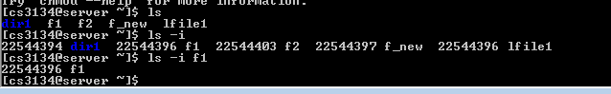

**ls –lX :** groups the file with same extensions together in the list

**Cal :** displays a calendar of the specified year or month

**Cal <year> :** displays a calendar of the specified year

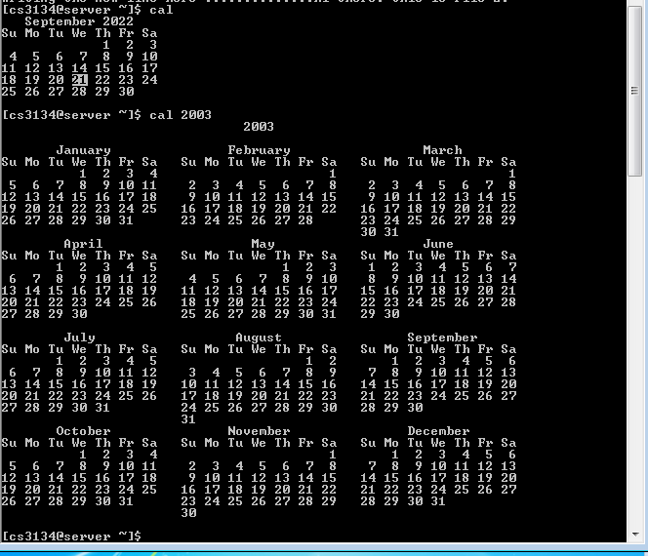

**Rm :** provides a way to insert remarks (that will not be acted on) into a batch file

**Man :**  used to display user manual of any command that we can run on the terminal

Shift+q : exit the manual

**Cp :**  copying files from one location to another

**vi <file name> :** enter contents into file

I : enter the insert mode in editor

Esc (in nano editor) ` : exit the insert mode

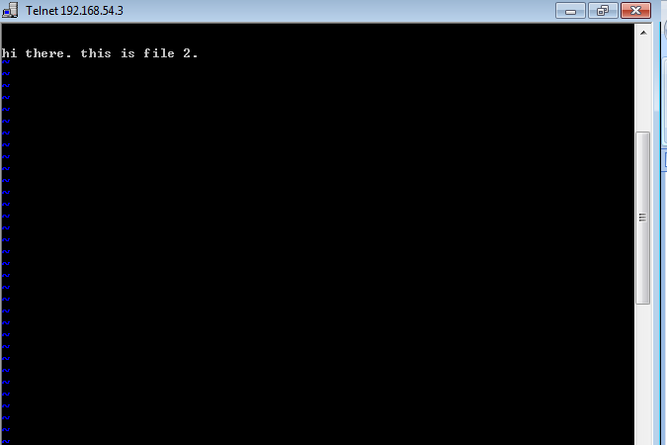

Shift + q : exit the editorp

**-wq : w** writes DATA from buffer into file and q is for quitting the editor

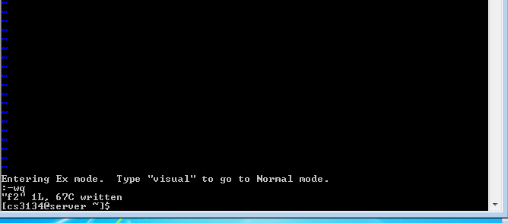

**Cat <file name> :** contents of file shown



**Cp <source file name> <destination file name – not created> :** copy the file with new name in same directory

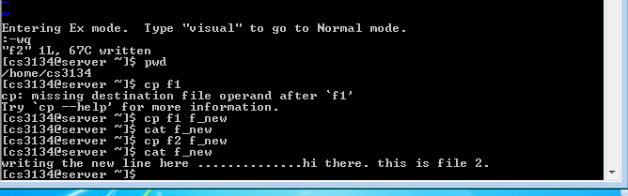

**First determine the complete path where you want your file to be copied**

**Cp <source file name> <destination file address/name> :** copy the file with new name in same directory

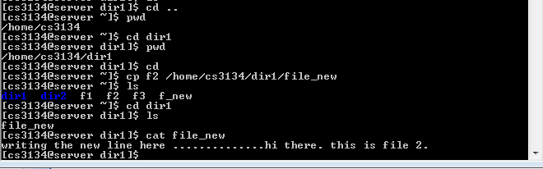

**ABSOLUTE AND RELATIVE PATH IN UNIX/LINUX**

**Absolute** starts from root and it goes as root/user/program/file/directory

**Relative path** refers to the path with respect to the relative position or current position in file.

**Ln <source file> <new file for link – not created> :**  create links to files or directories

**(the link count of the linked files changes from 1 to 2)**

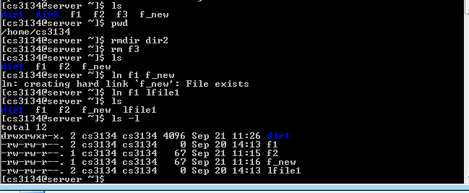

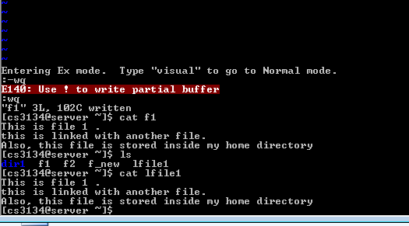

**Chmod < > <permission : r/w/e> :**

**User community in linux :**

**Mv <source file> <destination file> :**  when both the files are in same directory then mv works like rename otherwise.

Ls –I :